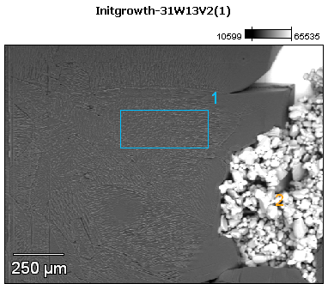

Image Name: Initgrowth-31W13V2(1)

Image Resolution: 512 by 384

Image Pixel Size: 3.09 µm

Acc. Voltage: 13.0 kV

Magnification: 80

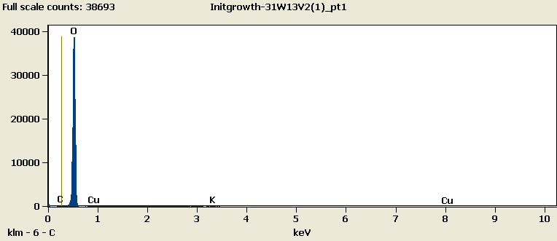

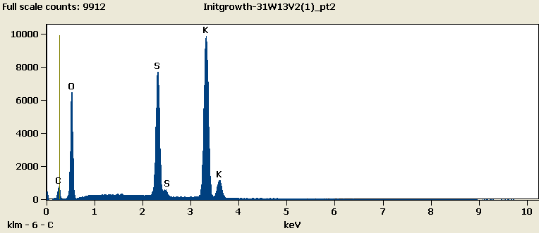

Weight %

|  |  |  |  |  |  |
| --- | --- | --- | --- | --- | --- |
|  | ***C-K*** | ***O-K*** | ***S-K*** | ***K-K*** | ***Cu-L*** |
| ***Initgrowth-31W13V2(1)_pt1*** | 0.05 | 95.17 |  | 0.21 | 4.58 |
| ***Initgrowth-31W13V2(1)_pt2*** | 5.82 | 34.63 | 18.96 | 40.59 |  |

Weight % Error (+/- 1 Sigma)

|  |  |  |  |  |  |
| --- | --- | --- | --- | --- | --- |
|  | ***C-K*** | ***O-K*** | ***S-K*** | ***K-K*** | ***Cu-L*** |
| ***Initgrowth-31W13V2(1)_pt1*** | ±0.09 | ±0.30 |  | ±0.04 | ±0.19 |
| ***Initgrowth-31W13V2(1)_pt2*** | ±0.17 | ±0.22 | ±0.10 | ±0.20 |  |

# Cations

|  |  |  |  |  |  |
| --- | --- | --- | --- | --- | --- |
|  | ***C-K*** | ***O-K*** | ***S-K*** | ***K-K*** | ***Cu-L*** |
| ***Initgrowth-31W13V2(1)_pt1*** | 0.00 | 0.00 |  | 0.00 | 0.00 |
| ***Initgrowth-31W13V2(1)_pt2*** | 0.00 | 0.00 | 0.00 | 0.00 |  |